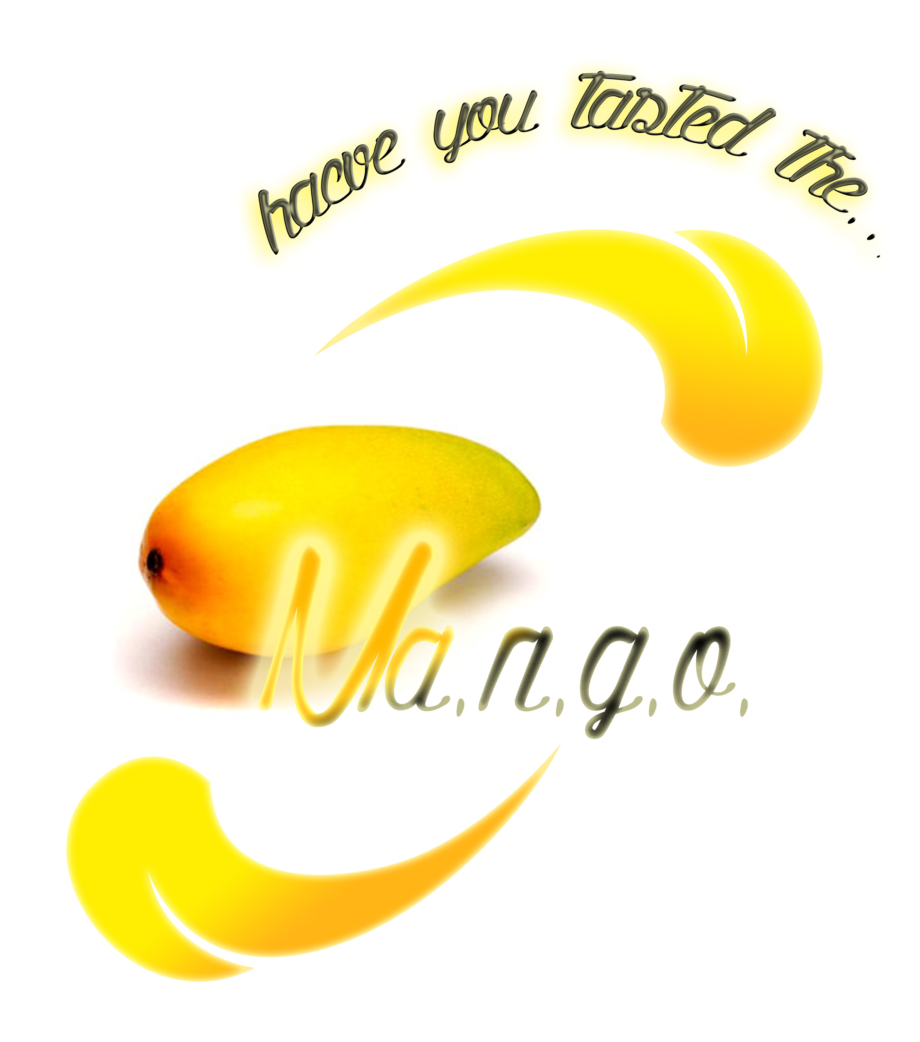
Call for partners
MA.N.G.O.
Management of Non Governmental Organisation
Capacity building seminar for NGOs on topics: Leadership, Organizational Management and Youth Participation

20 – 30 of May 2013
Thessaloniki, Greece
with the support of:
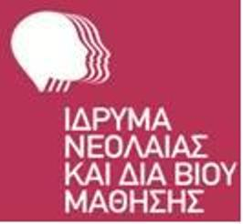
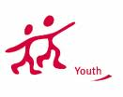
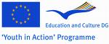

Background of the project:
The policy and programme of the Directorate of Youth and Sport of the Council is based onfour working priorities defined by its governmental and non-governmental partners in Agenda2020 set by the 8th Council of Europe Conference of Ministers responsible for youth and theCommittee of Ministers of the Council of Europe:

• Human rights and democracy: promoting the core valuesof the Council of Europe
• Living together in diverse societies:promotingintercultural dialogue
• Social inclusion of young people
• Policy approaches and instruments benefiting young people and children

Youth organisations are key partners in the planning and implementation of these projects,reflecting the philosophy of co-management between the governmental and nongovernmentalsectors. They also play a key role in the implementation of the programme,notably through study sessions and in running activities supported by the Youth in Action Program.
Active involvement in a youth organisation is one way for young people to participate in
society and to practise and exercise democratic power sharing. Therefore, welldeveloped anddedicated youth organisations are one of the prerequisites for greater participation of youngpeople in society. Many youth organisations experience challenges related to theirsustainability, as a result of sociological developments or/and as a result of youth policy changes.

Description:
Given that the role of youth organisations is also to be the voice of young people, trained toexercise democracy, they are irreplaceable partners in youth work and youth policy. Thesustainability of these youth organisations is therefore key to their effectiveness and theeffectiveness of youth policy.
An important component of their sustainability is related to the capacity of their leadership toorganise and mobilise their members, the young people, in ways that not only secure theviability of their projects but also, equally importantly, secure an effective democratic
participation and citizenship. Leadership skills are thus important in anyorganisation. But no one is born a youth leader: leadership and democracy can belearned and, moreover, can always be improved.
It is equally important to support the development of management practices of youth
organisations that enable sustainability and participation. At the level of Youth in Action Program this is especially relevant for those who develop and run international activities and whereintercultural processes are a daily reality and often represent an additional challenge.

During this period where the financial crisis is influent the social system and the young people are facing great issues to deal the important role of youth workers and ngos are getting clearer.

After a research that we have done among representatives of national and international NGO’s, we conclude that the majority of the stuff member of the youth NGO’s are youngsters who have slight knowledge on management, leadership and youth participationor they had never get train on topics connected with skills required for working place. The present edition of thiscourse builds on this research and the conclusions from that are towards promoting andsustaining the role of Youth NGOs.

In order to assure a quality youth work we propose this training course which aims to enable young people actively involved in the running of youthstructures to develop their attitudes, improve their skills and receive additional information andknowledge in order to manage youth organisations (programme, units or boards) in ademocratic, efficient and effective manner. Ultimately these improvements should result in anincrease of the quality of the activities these organisations run, in their sustainability and intheir contribution to youth policy bodies and structures.

MANGO is, however,more than a synthesis of three parts:
1. Leadership in youth structures – to introduce newcomers in international youth work to the existing international structures for youth participation and leadership.
2. Organizational management – to develop management capacities of youth organizations, to make them efficient, competent and sustainable.
3. Youth participation – foster the participation of young people in and trough youth projects (Youth in Action particularly)

These 10 days of training course are intended to serve as a “laboratory” for theyoung people – multipliers from SEE, and their supporting organisations, to secureconcrete impact and a response to real needs in the youth organisations.

Aim and objectives:
The main goal of the project is to strengthen the capacity and sustainabilityof youthorganisations by developing the competences of their leadership and
management structures.

More specific objectives are:

- To raise participants’ awareness and provide space to reflect upon the value of youthorganisations/structures - their role and impact as democratic leaders within society.
- To develop the participants’ ability to relate the work of their organisations with youthpolicy.
- To develop a common ground on concepts of leadership, democracy, participation, civil society, human rights and citizenship.
- To develop participants’ understanding and knowledge of various forms of youthparticipation through youth organisations.
- To introduce the main European institutions and organisations engaging in youth policydevelopment and implementation.
- To define and further develop leadership and civic competences as well as relevantmanagement skills (conflict management, advocacy, motivation, shared leadership,decision making, empowerment, strategic planning, resource management).
- To support participants in analyzing and further developing their organisation internalprocesses and mechanisms.
- To develop new skills on marketing of youth work and ways of volunteer recruitment and their motivation.
- To produce informal and formal networks for future collaboration
- How to apply for a grant under YiA or local municipalities.

APPROACH AND MAIN CONTENTS:
Democracy, Civil Society, Human Rights, Citizenship and Participation will be the core concepts as well as the basis for this training course.
Furthermore, the concept of youth policy, the role of youth organisations therein and the approaches of the main European institutions/organisations active in the field of youth policy will be introduced. The course program will also provide participants with the opportunity to develop their ability to contribute to the sustainability of youth organisations, including advocacy, democratic and shared leadership, empowering and motivating volunteers, bringing democratic and quality decisions, resource management, conflict management, development of organizational strategies and organizational learning. This training course will concentrate on youth organisations that are active at national and international level.
The course is founded in the conviction that non-formal education and intercultural learning are the basis of any educational process in youth work at European level. Furthermore, these two are very important for every process of organizational learning.
The course will empower the participants (who will be actively in touch with their board/secretariat and analyze their needs, as well as opportunities together) to introduce changes in their organisations. These changes, if democratic, multipliable and effective, should contribute to the development of the youth organisations and to greater youth policy, as well as youth participation in civil society, in general.

METHODOLOGY:
The course is designed as a mutual learning situation, where participants can experience andcompare different approaches to leadership, youth participation and managing youth organisations.
The course programme and contents are organised so as to encourage participation, sharedleadership and responsibility of the group, while using active and participatory methods.
Theprogramme of the training course will provide space for individual as well as group reflectionand debate, furthermore, take into account the experience of participants before, during andafter the course. Contributions from experts, visits, workshops and group work will help tocreate the theoretical and practical framework in which participants will reflect upon existingorganisational concepts and structures and how to develop them further. In this learningprocess, the youth organisation, in which the participants are active, will be involved throughopen communication channels. A team of experienced trainers organises the learning processand provides guidance to the participants’ personal development during the course.
A short preparation before the course and follow-up after the activity are planned through thee-learning platform.

TARGET GROUP:
Direct beneficiaries: The course is addressed to active members of international and national youth organisationsor other youth structures concerned by the sustainability of youth organisations (staff members, facilitators, volunteers, mentors, youth leaders).

PARTNERS AND PROCESS:
WE ARE SEARCHING FOR PARTNERS FROM EU COUNTRIES AND SEE COUNTRIES THAT ARE INTEREST TO INVOLVE IN THE PROJECT. WE WILL PRESENT THE APPLICATION TO THE GREEK NATIONAL AGENCY IN THE DEADLINE OF FIRST OF OCTOBER. PLEASE FIND THE ATTACHED DOCUMENT, FILL IT AND SENT BACK TO US AS SOON AS POSSIBLE. AFTER WE SELECT OUR PARTNERS WE WILL SENT YOU THE PART OF THE APPLICATION THAT YOU NEED TO SIGN AND STUMP AND SENT IT VIA FAX (0030 2310215629) OR AS SCAN VERSION TO OUR EMAIL INFO@USBNGO.GR
DEADLINE FOR EXPRESING YOUR INTEREST AND SENT YOUR ORGANISATION PROFILE IS 10TH OF SEPTEMBER!
For any further information do not hesitate to contact us.

